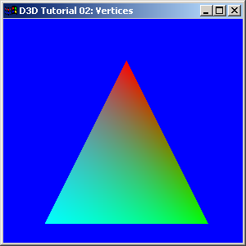
{50.0f, 250.0f, 0.5f, 2.0f, 0xff00ffff, },

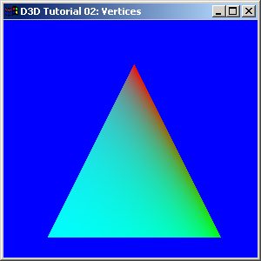
{50.0f, 250.0f, 0.5f, 8.0f, 0xff00ffff, },

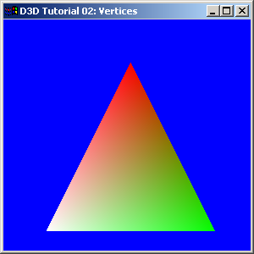
{ 50.0f, 250.0f, 0.5f, 1.0f, 0xffffffff, },

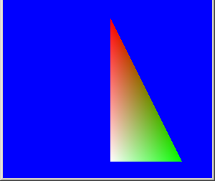
{ 150.0f, 250.0f, 0.5f, 1.0f, 0xffffffff, },

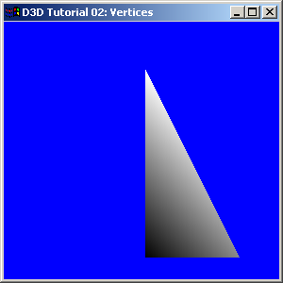
{ 150.0f, 50.0f, 0.5f, 1.0f, 0xFFFFFFFF, }, // x, y, z, rhw, color
{ 250.0f, 250.0f, 0.5f, 1.0f, 0x88888888, },
{ 150.0f, 250.0f, 0.5f, 1.0f, 0x00000000, },

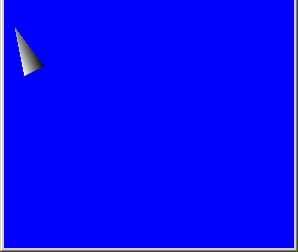
{ 20.0f, 100.0f, 0.5f, 1.0f, 0xFFFFFFFF, }, // x, y, z, rhw, color
{ 10.0f, 50.0f, 0.5f, 1.0f, 0x88888888, },
{ 40.0f, 90.0f, 0.5f, 1.0f, 0x00000000, },

